Subject: Discrete Mathematics
EXERCISES - CHAPTER 5&7: Counting

Book: Discrete Mathematics and Its Applications, 6th Edition
Author: Kenneth H. Rosen
Publisher: McGraw-Hill International Edition
Total: 17 exercises

344 | 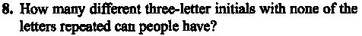  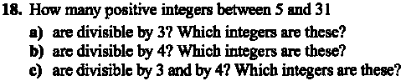
345 | 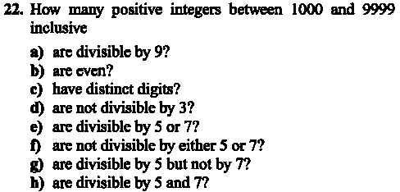  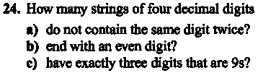  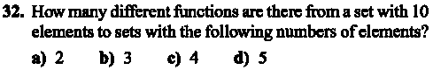
346 | 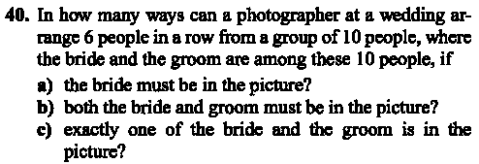  
387
456 | 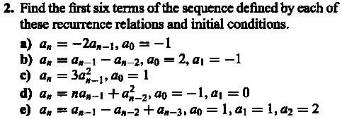  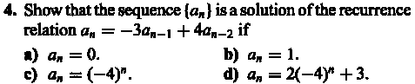
457 | 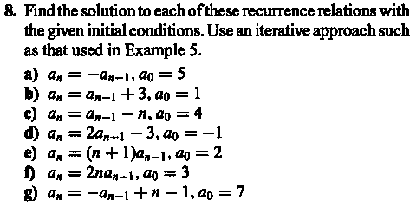  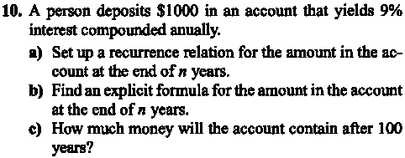  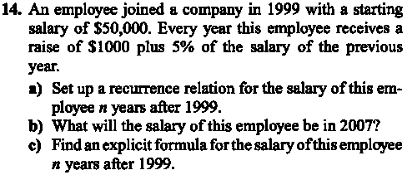  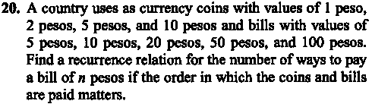
482 | 